1. Create project

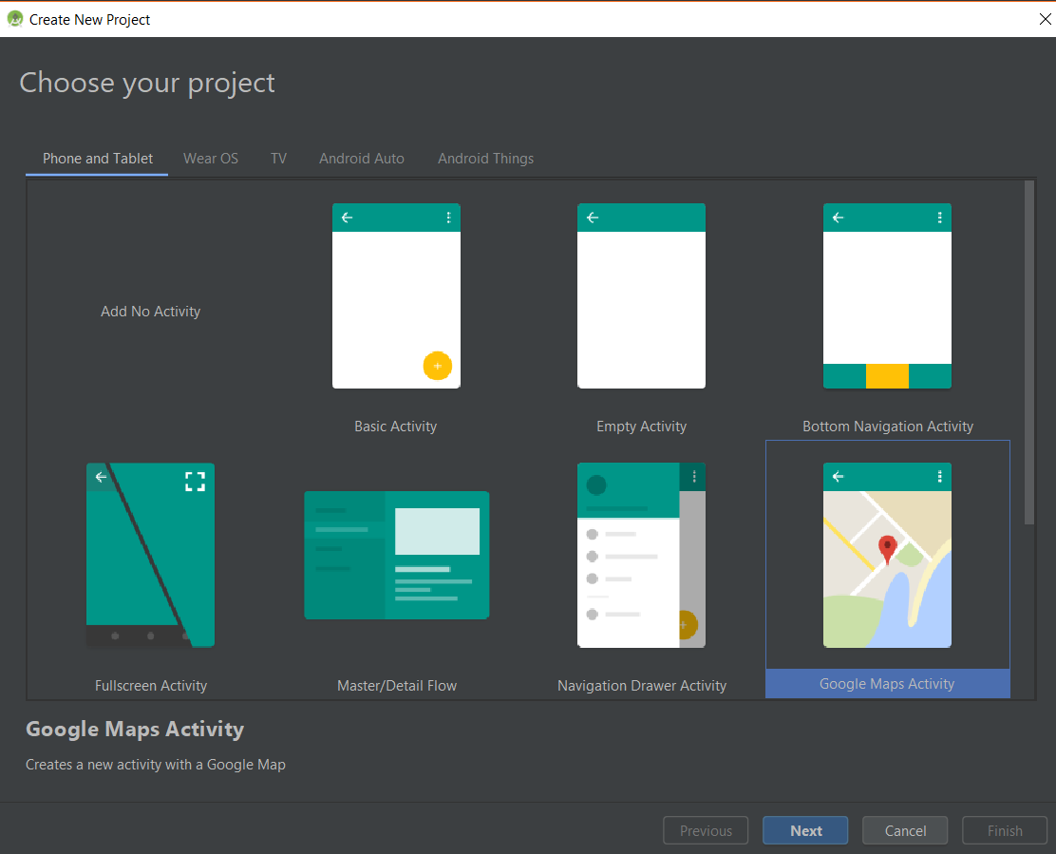

1. Set up map API, go to google_maps_api.xml under /res/values

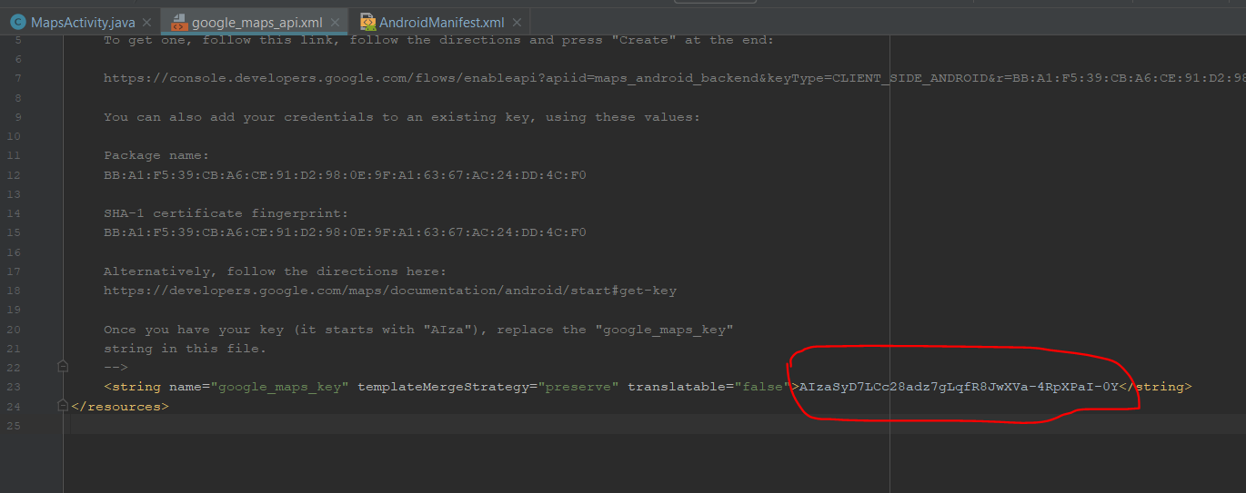

1. Code your program in MapsActivity
2. Connecting to firebase

Go to Tools=>Firebase. Then follow the guide

Code explanation:

1. Import all relevant library
2. package com.example.runtah;  
     
   import android.content.res.Resources;  
   import android.support.v4.app.FragmentActivity;  
   import android.os.Bundle;  
   import android.util.Log;  
     
   import com.google.android.gms.maps.CameraUpdateFactory;  
   import com.google.android.gms.maps.GoogleMap;  
   import com.google.android.gms.maps.OnMapReadyCallback;  
   import com.google.android.gms.maps.SupportMapFragment;  
   import com.google.android.gms.maps.model.BitmapDescriptorFactory;  
   import com.google.android.gms.maps.model.CameraPosition;  
   import com.google.android.gms.maps.model.LatLng;  
   import com.google.android.gms.maps.model.MapStyleOptions;  
   import com.google.android.gms.maps.model.MarkerOptions;  
     
   import com.google.firebase.database.DataSnapshot;  
   import com.google.firebase.database.DatabaseError;  
   import com.google.firebase.database.DatabaseReference;  
   import com.google.firebase.database.FirebaseDatabase;  
   import com.google.firebase.database.ValueEventListener;